
QUALITY MANAGEMENT SYSTEM
DAN Quality Management System
Quality Management Manual

Document Control
Document No. | 01-000001-000000-DAN-QMN-MAN-000001 | Revision | R00
Issue Date | June 2026 | Classification | Controlled — Internal
Document Owner | Quality Department | Page Format | US Letter
Approval
Prepared By | Reviewed By | Approved By
Quality Manager  Signature / Date | Amjed Sammari  Delivery Director  Signature / Date | AbdulHalim Kaissy  Chief Development Officer (CDO)  Signature / Date

Table of Contents

Document Control — Review and Approval
Executive Summary
Purpose
Mission and Vision
Quality Commitment
Scope of Application
Key Quality Objectives
Governance and Continual Improvement
1. Introduction
1.1 Organisational Background
1.2 Purpose of the Quality Manual
1.3 Alignment with ISO 9001:2015
2. Quality Management Principles
3. Terms, Abbreviations and Acronyms
4. Context of the Organisation
4.1 Understanding the Organisation and its Context
4.2 Needs and Expectations of Interested Parties
4.3 Scope of the Quality Management System
4.4 Quality Management System and its Processes
5. Leadership
5.1 Leadership and Commitment
5.2 Customer (Client) Focus
5.3 Quality Policy
5.4 Organisational Roles, Responsibilities and Authorities
6. Planning
6.1 Actions to Address Risks and Opportunities
6.2 Quality Objectives and Planning to Achieve Them
6.3 Planning of Changes
7. Support
7.1 Resources
7.2 People and Competence
7.3 Infrastructure
7.4 Environment for the Operation of Processes
7.5 Monitoring and Measuring Resources
7.6 Organisational Knowledge
7.7 Awareness
7.8 Communication
7.9 Documented Information
8. Operation
8.1 Operational Planning and Control
8.2 Requirements for the Works
8.3 Design Coordination and Development
8.4 Control of Externally Provided Processes, Products and Services
8.5 Construction and Service Provision
8.6 Release of the Works
8.7 Control of Non-Conforming Outputs
9. Performance Evaluation
9.1 Monitoring, Measurement, Analysis and Evaluation
9.2 Client Satisfaction
9.3 Analysis and Evaluation
9.4 Internal Audit
9.5 Management Review
10. Improvement
10.1 General
10.2 Non-Conformity and Corrective Action
10.3 Continual Improvement
Annex A.1 — ISO 9001:2015 Clause Correlation Matrix
Annex A.2 — QMS Process Interaction Overview
Annex A.3 — DAN Organisation and Delivery Tiers
Annex A.4 — QMS Document Index
Revision History

Document Control — Review and Approval
This Quality Manual is a Quality Function document, prepared, reviewed and approved by the relevant quality personnel.
Action | Name | Role | Date
Prepared by | Quality Manager | Quality Department | June 2026
Reviewed by | Amjed Sammari | Delivery Director | June 2026
Approved by | AbdulHalim Kaissy | Chief Development Officer (CDO) | June 2026
Amendment History
Version | Date | Details
v00 | June 2026 | First issue — development of the DAN Quality Management System and Manual.

Executive Summary

Purpose
This Quality Manual provides a unified framework for ensuring that DAN Company consistently delivers high-quality, safe and sustainable construction projects that meet the requirements of its Clients and the applicable codes and standards. It aligns with ISO 9001:2015 and supports the Kingdom's Vision 2030 objectives, embedding quality into every stage of the project life cycle — from planning and procurement through construction to commissioning and handover.

Mission and Vision
- Mission: deliver building and infrastructure projects of consistently high quality, safely and on time, that meet our Clients' requirements and serve the communities in which we work.
- Vision: to be a trusted and innovative construction delivery organisation in the Kingdom, where quality is built into every project.

Quality Commitment
DAN's leadership commits to:
- Client First — meet or exceed Client and end-user requirements through reliable, well-controlled delivery.
- Compliance — meet or surpass all regulatory, statutory and contractual requirements.
- Governance and Accountability — clear decision rights through a Matrix of Authority (MOA), RACI matrices and stage-gate reviews.
- Continual Improvement — embed the Plan-Do-Check-Act (PDCA) cycle and lessons learned in all processes.
- Digital and Innovation — use Building Information Modelling (BIM), a Common Data Environment (CDE), project-management information systems and data analytics to assure quality.

Scope of Application
The Quality Management System (QMS) applies to all DAN operations, including: the planning, procurement, construction, commissioning and handover of building, civil and infrastructure projects; supporting functions (procurement, HR, finance, IT, HSSE, compliance); and externally provided processes (the Project Management Consultant, contractors, subcontractors, consultants and suppliers).

Key Quality Objectives
- Achieve and maintain ISO 9001:2015 conformity.
- Achieve ≥ 95% defect-free handovers (final inspections without major defects) across projects.
- Achieve ≥ 90% Client satisfaction at handover.
- Reduce rework / cost of poor quality by 15–20% annually.
- Ensure 100% compliance in regulatory and contractual quality audits.

Governance and Continual Improvement
- Governance: Matrix of Authority (MOA), RACI matrices and stage-gate reviews provide structured checkpoints aligned with strategy, quality and risk.
- Continual improvement: internal audits (corporate, functional, project and supplier), Client feedback, corrective action and lessons learned (NCRs, RCA, trend analysis), and periodic management reviews by the leadership team.

1. Introduction

1.1 Organisational Background
DAN Company is a Saudi construction project-delivery organisation committed to delivering building and infrastructure projects across the Kingdom in support of Vision 2030. DAN manages the delivery of its projects through their full life cycle — from planning and procurement through construction to commissioning and handover — directing delivery through a Project Management Consultant (PMC) and its appointed contractors and subcontractors, and engaging consultants, suppliers and the relevant authorities.
This Quality Manual defines the framework of the DAN Quality Management System (QMS), describing how corporate and project activities are planned, executed, verified and improved to ensure consistent quality outcomes, Client satisfaction and regulatory compliance. It provides all personnel, the PMC, consultants and contractors with a common understanding of how quality is managed across the organisation and its projects.

1.2 Purpose of the Quality Manual
The purpose of this Manual is to:
- Establish a structured and unified approach to quality management across DAN and its projects.
- Demonstrate conformity with the requirements of ISO 9001:2015.
- Define the roles, responsibilities and authorities for achieving quality objectives.
- Provide reference and direction for the development and continual improvement of subordinate QMS procedures, templates and records.

1.3 Alignment with ISO 9001:2015
The QMS is structured on the ISO 9001:2015 framework and follows the Plan-Do-Check-Act (PDCA) cycle and risk-based thinking. All requirements of ISO 9001:2015 are applicable except where specifically excluded and justified in the management-review records. The QMS is integrated with DAN's HSE Management System so that quality, health, safety, security and environment (QHSSE) are managed in a coordinated way.

2. Quality Management Principles
The QMS is founded on the seven quality-management principles of ISO 9001:2015, each translated into practical actions within DAN's construction-delivery context:
Principle | DAN application / practice
Customer (Client) focus | Client and end-user requirements drive design coordination and delivery decisions; satisfaction is monitored through inspections, a Project Quality Index and handover feedback to achieve ≥ 90% satisfaction.
Leadership | Leadership defines the vision, policy and values, exercised through the Matrix of Authority, stage-gate reviews and visible "quality-first" commitment.
Engagement of people | Empowered, competent teams own quality at every level, supported by competency frameworks, training plans and awareness sessions.
Process approach | Delivery follows a defined life cycle (Plan → Design coordination → Build → Handover → Improve), with process maps and interaction matrices ensuring control.
Improvement | Lessons learned, corrective and preventive action (CAPA) and continual-improvement registers drive efficiency and innovation.
Evidence-based decision making | Dashboards, KPI analytics and reports convert site data into insight for management reviews and decisions.
Relationship management | Long-term relationships with the PMC, contractors, consultants and suppliers are sustained through prequalification, performance evaluation and mutual trust.

3. Terms, Abbreviations and Acronyms
Abbreviation | Definition
QMS | Quality Management System
QHSSE | Quality, Health, Safety, Security and Environment
CDO | Chief Development Officer
PMC | Project Management Consultant
PMT | Project Management Team
QA / QC | Quality Assurance / Quality Control
ITP | Inspection and Test Plan
IR | Inspection Request
IFC | Issued for Construction (drawings/documents)
NCR | Non-Conformance Report
CAPA | Corrective and Preventive Action
RCA | Root Cause Analysis
OFI | Opportunity for Improvement
DLP | Defects Liability Period
PQMP | Project Quality Management Plan
MOA | Matrix of Authority
RACI | Responsible, Accountable, Consulted, Informed (roles matrix)
BIM / CDE | Building Information Modelling / Common Data Environment
EDMS | Electronic Document Management System
KPI | Key Performance Indicator
PDCA | Plan-Do-Check-Act cycle
CoPQ | Cost of Poor Quality
R&O | Risks and Opportunities
SASO / GSO | Saudi Standards, Metrology and Quality Organization / GCC Standardization Organization
Vision 2030 | Kingdom of Saudi Arabia National Transformation Program 2030

4. Context of the Organisation

4.1 Understanding the Organisation and its Context
DAN operates within the Kingdom's rapidly evolving construction sector, influenced by national programmes such as Vision 2030. DAN determines the internal and external issues relevant to its purpose and strategic direction that affect the QMS, reviewing them during management reviews and strategic-planning sessions.
Internal factors
- Organisational structure, governance and leadership commitment.
- Core values: Quality, Integrity, Client Focus, Safety, Innovation and Responsibility.
- Competence and engagement of employees and delivery partners.
- Standardised quality protocols and digital frameworks (EDMS/CDE, BIM, business-intelligence dashboards).
External factors
- National transformation initiatives (Vision 2030).
- Regulatory and statutory frameworks for construction (Saudi Building Code, authorities' requirements).
- Market conditions and the availability of materials, plant and skilled labour.
- Technological advances in BIM, digital construction and modern methods of construction.
- Environmental, sustainability and community expectations.

4.2 Needs and Expectations of Interested Parties
Interested party | Needs and expectations
Clients / Owners | High-quality, defect-free projects delivered safely, on time and to specification; reliable reporting and responsive support; effective defects-liability support.
Government / Regulators | Compliance with the Saudi Building Code, statutory requirements and Vision 2030 objectives.
Owners / Shareholders | Transparency, performance and effective risk control.
Employees & Consultants | Clear roles, development and a positive quality culture.
PMC / Contractors / Suppliers | Clear requirements, fair procurement, mutual benefit and timely payment.
Community & Society | Sustainability, social responsibility and environmental protection.

4.3 Scope of the Quality Management System
Scope statement: This Quality Management System applies to all planning, procurement, construction, commissioning and handover activities executed by DAN Company throughout the Kingdom of Saudi Arabia, covering corporate functions and project operations for building, civil and infrastructure projects, together with the support services that influence the quality of the delivered works.
All requirements of ISO 9001:2015 are applicable except where specifically excluded and justified in the management-review records. Where DAN does not itself perform detailed design (design being undertaken by appointed design consultants), DAN controls design as an externally provided process (Clause 8.4) and through design-coordination and review activities (Clause 8.3).

4.4 Quality Management System and its Processes
DAN has adopted a process approach in which inputs, activities, outputs and interactions are clearly defined, measured and continually improved. The core process groups are:
- Leadership and planning processes — strategic direction, policy, objectives and risk management.
- Client and stakeholder processes — requirement analysis, contract/scope review and communication.
- Delivery processes — design coordination, procurement, construction, inspection and testing, and handover.
- Evaluation and improvement processes — audits, KPI tracking, lessons learned and CAPA.
Each process is supported by documented procedures, flowcharts and forms maintained in the EDMS; performance is monitored through KPIs and reviewed periodically by management. Externally provided (outsourced) activities are controlled through procurement procedures, contractual requirements and second-party audits so that the PMC, contractors and suppliers maintain DAN's quality standards. The QMS process interaction is summarised in Annex A.2.

5. Leadership

5.1 Leadership and Commitment
DAN's leadership — the Chief Executive Officer (CEO), the Chief Development Officer (CDO) and the Delivery Director, supported by the Quality function — demonstrates full commitment to establishing, implementing and continually improving the QMS, ensuring it achieves its intended results and drives Client satisfaction, compliance and organisational excellence. Key leadership responsibilities include:
- Establishing the vision, mission and strategic direction consistent with Vision 2030.
- Establishing the Quality Policy and objectives, compatible with the strategic direction.
- Integrating the QMS requirements into DAN's business processes and providing adequate resources.
- Promoting a culture of integrity, quality and innovation, and the process approach and risk-based thinking.
- Ensuring alignment between QMS objectives and business strategy, supported by evidence-based decision making.

5.2 Customer (Client) Focus
Client satisfaction is the principal measure of success at DAN. Leadership ensures that Client and applicable statutory/regulatory requirements are determined, understood and consistently met; that risks and opportunities affecting conformity are addressed; and that the focus on enhancing Client satisfaction is maintained. Requirements are reviewed, feedback and complaints are captured and resolved, and satisfaction is monitored through inspections, the Project Quality Index and handover evaluations, with corrective and preventive actions initiated where necessary.

5.3 Quality Policy
DAN's Quality Policy provides the strategic framework for all activities, stating the organisation's commitment to: delivering high-quality, safe and sustainable projects; achieving Client satisfaction of at least 90%; complying with all legal, statutory and contractual obligations; embedding a culture of continual improvement through training, audits and lessons learned; and upholding leadership accountability and transparent communication. The Policy is reviewed at least annually (and on significant change), communicated to all staff through inductions and awareness sessions, and made available to interested parties as documented information.
PDCA — DAN Delivery Life-Cycle Model
DAN applies the Plan-Do-Check-Act methodology as the foundation of leadership oversight and process control, adapted to the construction-delivery life cycle:
PDCA stage | DAN life-cycle phase | Key activities | Outputs / records
Plan | Strategic planning & design coordination | Define objectives, allocate resources, set KPIs, approve project plans, identify risks and opportunities. | QMS objectives register, risk register, PQMP.
Do | Procurement & construction execution | Implement approved methods, engage the PMC and contractors, monitor progress, ensure compliance and safety. | ITP records, inspection requests, progress reports.
Check | Verification & handover readiness | Measure performance, audit processes, analyse Client feedback, evaluate compliance. | Audit reports, Client satisfaction, PQI dashboards.
Act | Improvement & knowledge sharing | Review results, hold management reviews, capture lessons learned, revise QMS documents. | Management-review minutes, CAPA records, lessons-learned register.

5.4 Organisational Roles, Responsibilities and Authorities
DAN uses a Matrix of Authority (MOA) and a RACI matrix to define clear responsibilities for all QMS-related activities. Authority for approvals, reviews and sign-offs follows the MOA and is traceable through project documentation and the EDMS.
Role / function | Key responsibilities
CEO / CDO / Board | Endorse the Quality Policy and objectives; ensure alignment with Vision 2030 and the strategic direction.
Delivery Director | Provide leadership and resources for the QMS; chair management reviews; accountable for delivery quality.
Quality Manager | Lead QMS governance; prepare and maintain the quality manual, procedures and audit plans; maintain QMS documents; monitor KPIs and report to leadership.
Project Quality Manager / Engineer | Implement the QMS on projects; manage inspection and testing; issue and close NCRs and reports; oversee the PMC/contractor quality.
Functional Managers (HR, Procurement, Design, Construction) | Ensure departmental processes align with QMS requirements.
PMC, Contractors and all Employees | Follow approved procedures; report issues; contribute to continual improvement.

6. Planning

6.1 Actions to Address Risks and Opportunities
DAN adopts a proactive, hierarchical approach to managing risks and opportunities so that the QMS achieves its intended results, enhances desirable outcomes and prevents undesired effects. Risk-based thinking is embedded at every level:
- Strategic level — enterprise and reputational risks evaluated by leadership during business planning.
- Programme level — operational efficiency, schedule and resource risks managed by Programme/Delivery Directors.
- Project level — technical, design-coordination and construction risks controlled by the Project Management Team and QA/QC.
- Process level — day-to-day risks identified through ITPs, inspections and field audits.
Each level maintains a Risk and Opportunity Register identifying the description, likelihood, impact, owner and mitigation/exploitation measures. Leadership ensures adequate resources for mitigation, reviews audit findings and performance data to update risk profiles, and uses lessons learned from prior projects to inform planning. Actions are documented and tracked to closure during management reviews.

6.2 Quality Objectives and Planning to Achieve Them
DAN establishes measurable, realistic and time-bound quality objectives at corporate, programme and project levels, consistent with the Quality Policy, aligned with stakeholder and regulatory requirements, and expressed as quantitative KPIs with defined baselines and targets:
No. | Objective | KPI / metric | Target | Responsible
1 | Maintain ISO 9001:2015 conformity | Certification / audit status | Maintained | Quality Manager
2 | Deliver defect-free projects | % final inspections without major defects | ≥ 95% | Project QA/QC
3 | Maintain Client satisfaction | Survey / PQI score | ≥ 90% | QA & Client Relations
4 | Reduce rework cost | Cost of poor quality ratio | ↓ 15% annually | Construction Team
5 | Ensure regulatory compliance | Compliance rate in audits | 100% | Compliance Officer
Progress is reviewed monthly via dashboards and quarterly during management reviews; missed targets trigger corrective action through the CAPA system.

6.3 Planning of Changes
DAN manages change in a structured manner to safeguard the integrity of the QMS. Potential impacts are evaluated before implementation; changes are communicated and training provided; related documented information (procedures, templates, registers) is updated; and the effectiveness of the change is monitored. Changes may relate to organisational structure, project scope, process updates or external factors (e.g. new regulations). Significant changes are reviewed and approved by the relevant authority per the MOA and recorded in the QMS Improvement Register.

7. Support

7.1 Resources
DAN determines and provides the resources needed to establish, implement, maintain and continually improve the QMS — competent personnel, adequate infrastructure, reliable equipment, digital systems and financial support — and reviews resource adequacy through management reviews, project audits and capacity-planning meetings.

7.2 People and Competence
DAN ensures that all personnel performing work affecting quality are competent on the basis of education, training and experience. Job descriptions specify required qualifications; recruitment and appraisal verify and document competency; training plans address technical and behavioural competency gaps; effectiveness is evaluated through assessments, audits and KPIs; and records of qualifications and training are maintained by HR in the EDMS.

7.3 Infrastructure
Infrastructure required for conformity of the works includes offices, construction sites, laboratories and welfare facilities; equipment, IT systems, networks and communications; and supporting utilities and services (logistics, calibration, maintenance). Facilities are maintained under approved schedules, and equipment calibration/inspection requirements are defined in the Monitoring and Measurement procedure.

7.4 Environment for the Operation of Processes
DAN maintains safe, secure and environmentally responsible workplaces under the corporate QHSSE framework integrated with the HSE Management System: site conditions (lighting, ventilation, ergonomics) are reviewed; welfare, sanitation and emergency arrangements meet statutory requirements; and environmental controls mitigate adverse weather and sustainability impacts. Safety-audit and environmental-monitoring records are retained as quality evidence.

7.5 Monitoring and Measuring Resources
DAN ensures that monitoring and measuring devices are calibrated or verified at defined intervals against traceable national or international standards. Calibration certificates are maintained in the EDMS; equipment status (in-calibration / out-of-service) is visibly identified; non-conforming tools are quarantined and results re-validated; and measurement software (e.g. BIM validation, survey tools) is verified by the IT and Quality teams.

7.6 Organisational Knowledge
Organisational knowledge is treated as a strategic asset, drawn from project data, lessons learned, benchmarking and expert know-how, and captured through lessons-learned registers and close-out reports, communities of practice and mentoring, documented procedures and design standards, and external forums. Periodic reviews keep the information current, accessible and aligned with strategic goals.

7.7 Awareness
DAN promotes organisation-wide awareness of the Quality Policy and objectives, each person's contribution to the effectiveness of the QMS, and the implications of non-conformance — reinforced through inductions, tool-box talks, newsletters and leadership communications.

7.8 Communication
- Internal: quality objectives, performance, risks and opportunities are shared through coordination meetings, dashboards, corporate communications and KPI briefings.
- External: engagement with regulators, Clients, the PMC, contractors and suppliers is managed via structured communication plans and documented, traceable correspondence held in the EDMS.

7.9 Documented Information
DAN maintains the documented information required by ISO 9001:2015 and any additional information necessary for effective operation. Each controlled document includes a title, document number and revision status; author, reviewer and approver; issue/revision dates; and EDMS distribution status. The EDMS governs approval and re-approval before issue, identification of current versions and prevention of obsolete use, secure access with revision history and audit trail, and retention of records for at least 10 years or as contractually required.

8. Operation

8.1 Operational Planning and Control
Operations are planned and controlled through corporate and project-specific management plans. Each project defines the objectives and requirements for the deliverables; verification, validation and inspection controls; applicable statutory and contractual obligations; and resources and responsibilities. Outputs of planning include approved Project Quality Management Plans (PQMPs), ITPs, schedules and inspection plans maintained in the EDMS.

8.2 Requirements for the Works
- Client communication: DAN maintains open, timely communication with the Client and stakeholders across all project phases; feedback and complaints are captured, analysed and used to drive improvement.
- Determining and reviewing requirements: all Client, regulatory and internal requirements are identified, reviewed and documented before acceptance of any contract or change order; pre-award and pre-start reviews confirm that requirements are clear, feasible and free of conflict, and that capability, capacity and compliance are verified. Records are retained as quality evidence.
- Changes to requirements: changes to Client or regulatory requirements are evaluated, approved and communicated to all affected parties, with EDMS traceability of revisions.

8.3 Design Coordination and Development
Where design is undertaken by appointed design consultants, DAN coordinates, reviews and controls design so that outputs meet the intended use and stakeholder requirements. Design planning defines stages, reviews, responsibilities, verification, validation and resources; inputs include functional requirements, statutory codes, DAN standards and lessons learned; designs are reviewed, verified and validated at defined stages using peer review, mock-ups and digital coordination (BIM/CDE); outputs provide sufficient information for construction and procurement (specifications and Issued-for-Construction drawings); and design changes are logged, assessed for impact, reviewed and approved before implementation.

8.4 Control of Externally Provided Processes, Products and Services
All externally provided works, materials and services — including those of the PMC, contractors, subcontractors and suppliers — must conform to DAN's quality, safety and contractual requirements. Controls include prequalification and performance evaluation of suppliers; formal kick-off meetings to communicate quality expectations; contract clauses specifying QA/QC, reporting and audit rights; and monitoring through inspections, audits and KPI tracking. Results feed into the Supplier Evaluation Register.

8.5 Construction and Service Provision
- Control: construction and delivery activities are executed under approved PQMPs and ITPs, under controlled conditions — current design information, qualified personnel and calibrated equipment, monitoring and inspection at defined stages, and records of conformity (checklists, test reports).
- Identification and traceability: materials, components and outputs are identified by batch, location or serial number to ensure traceability from procurement through handover.
- Property of Clients/external providers: Client or third-party property (documents, materials, tools) is safeguarded and recorded; loss or damage is reported and investigated.
- Preservation: preservation measures prevent deterioration of materials and works during storage, transport and installation.
- Post-delivery activities: include maintenance of records, feedback handling and support during the Defects Liability Period (DLP).
- Control of changes: operational changes affecting quality are reviewed, approved and documented, with risk analysed before implementation.

8.6 Release of the Works
Works are released (and milestones/handover certified) only after all specified inspections and tests have been successfully completed and evidence of conformity is verified. Authorisations are documented via release certificates or inspection sign-offs (Inspection Requests) in the EDMS.

8.7 Control of Non-Conforming Outputs
Non-conforming work is promptly identified, segregated and controlled to prevent unintended use. The process includes issue of a Non-Conformance Report (NCR); root-cause analysis and corrective action; re-inspection and verification of the corrected work; and approval of a concession where applicable. NCRs are tracked in the NCR & CAPA Register and reviewed in management meetings to prevent recurrence.

9. Performance Evaluation

9.1 Monitoring, Measurement, Analysis and Evaluation
DAN applies suitable methods to determine which QMS processes require monitoring and how frequently, addressing process efficiency, Client satisfaction, supplier performance and compliance. Inputs include audit and inspection data, KPI dashboards (Project Quality Index), Client feedback and complaints, and regulatory compliance reports; outputs include performance scorecards, trend analyses, corrective-action summaries and management-review findings. Results are evaluated against established control limits, and deviations trigger root-cause investigation or corrective action.

9.2 Client Satisfaction
Client satisfaction is monitored and analysed to determine whether expectations are met, through handover surveys and inspection reports, PQI scorecards, and analysis of complaints, response times and closure rates. Results are reported to leadership each quarter; where ratings fall below 90%, corrective-action plans are initiated.

9.3 Analysis and Evaluation
Data from audits, inspections, KPI dashboards and Client feedback are consolidated and analysed using statistical methods to identify trends, recurring defects and improvement priorities. Performance metrics include conformity to design and construction specifications, audit compliance rate, on-time delivery of milestones, cost of poor quality (CoPQ) and supplier evaluation ratings. Findings feed directly into management reviews and the continual-improvement programme.

9.4 Internal Audit
DAN conducts internal audits at planned intervals to determine whether the QMS conforms to ISO 9001:2015 and corporate requirements and is effectively implemented and maintained, under the Internal Audit procedure and an annual audit programme. Audit types include corporate audits (policy, governance, leadership), functional audits (HR, Procurement, Design, Finance), project audits (construction and handover) and supplier audits (PMC/contractor performance). Findings, observations and Opportunities for Improvement (OFIs) are recorded, non-conformities are registered in the CAPA log, and outcomes are presented during management reviews.

9.5 Management Review
At least annually, top management reviews the QMS to ensure its continuing suitability, adequacy and effectiveness. Inputs include internal/external audit results, KPI trends and Client feedback, NCR and CAPA status, risk and opportunity registers, performance against objectives, and resource and training adequacy. Outputs include decisions and actions for improvement, revisions to the policy and objectives, resource/budget allocations, and approval of new initiatives. Minutes are retained as controlled records in the EDMS for at least 10 years.

10. Improvement

10.1 General
DAN is committed to systematic and continual improvement of its QMS and operational performance. Opportunities arise from risk reviews, audits, inspections, feedback and strategic analysis, and may include process optimisation, training enhancement, digital automation or policy revision. Improvement progress is tracked via the QMS Improvement Register and reviewed by leadership during management reviews.

10.2 Non-Conformity and Corrective Action
Non-conformities are addressed immediately to eliminate causes and prevent recurrence, under the Control of Non-Conforming Condition procedure: identification and containment of the non-conforming output; recording on the NCR form and CAPA register; root-cause analysis (e.g. 5-Whys or Fishbone); implementation of corrective and preventive actions; and verification of effectiveness through follow-up audits. Effectiveness criteria: the issue is resolved, there is no recurrence, Client satisfaction is maintained, and lessons are shared.

10.3 Continual Improvement
DAN encourages all employees and partners to identify areas for enhancement. Continual improvement is achieved through data-driven decision making and trend analysis, digital quality dashboards, innovation initiatives and process automation, and lessons-learned reviews and cross-project benchmarking. Improvements are validated for effectiveness and communicated organisation-wide.

Annex A.1 — ISO 9001:2015 Clause Correlation Matrix
ISO clause | Requirement | Manual ref. | Linked procedure / record
4.1 | Context of the organisation | 4.1 | SWOT & PESTLE / context register
4.2 | Needs & expectations of interested parties | 4.2 | Stakeholder matrix
4.3 | Scope of the QMS | 4.3 | Scope statement
4.4 | QMS and process interactions | 4.4 | Process map (Annex A.2)
5.1–5.3 | Leadership / policy / roles | 5 | MOA / RACI matrix; Quality Policy
6.1–6.3 | Planning & risk management | 6 | Risk & Opportunity register
7.1–7.5 | Support / resources | 7 | Competence & Training procedure
8.1–8.7 | Operation | 8 | PQMP, ITP, method statements
9.1–9.3 | Performance evaluation | 9 | Audit plan, PQI tool
10.1–10.3 | Improvement | 10 | CAPA register, lessons learned

Annex A.2 — QMS Process Interaction Overview
Process group | Core processes | Key inputs | Key outputs
Leadership & Planning | Strategic direction, governance, policy deployment | Vision 2030 targets, risk register | Approved policy & objectives
Client & Stakeholder | Requirement analysis, contract review, communication | Client requirements, contracts | Approved requirements, feedback reports
Design Coordination | Design review, coordination, value engineering | Design inputs, standards | IFC drawings, BIM models
Construction & Delivery | Procurement, execution, inspection & testing | IFC drawings, materials | Completed works, ITP records
Evaluation & Improvement | Audits, KPI review, management review | Inspection data, Client feedback | Improvement actions, CAPA
Support | HR, finance, procurement, IT, EDMS | Policies, resource needs | Competent people, controlled documents

Annex A.3 — DAN Organisation and Delivery Tiers
DAN's corporate quality governance runs from the CEO through the CDO and the Delivery Director to the Quality Manager who leads the quality function. On each project, DAN (as Employer/Client) directs delivery through the PMC, which manages and supervises the Contractor:
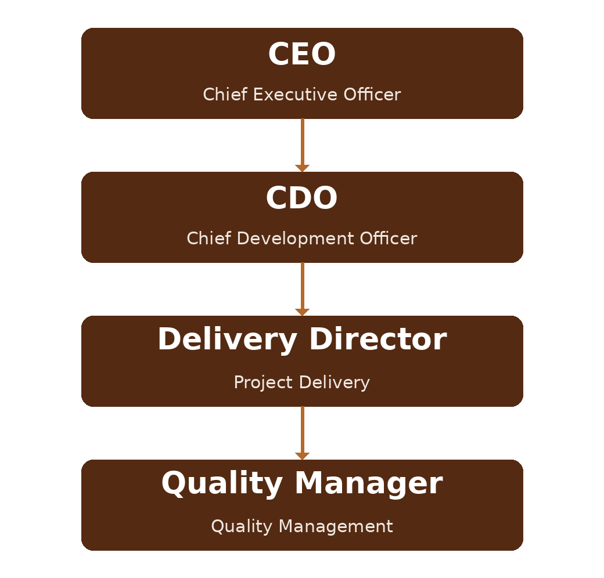
Figure A.3.1 DAN Corporate Organisation (quality governance)
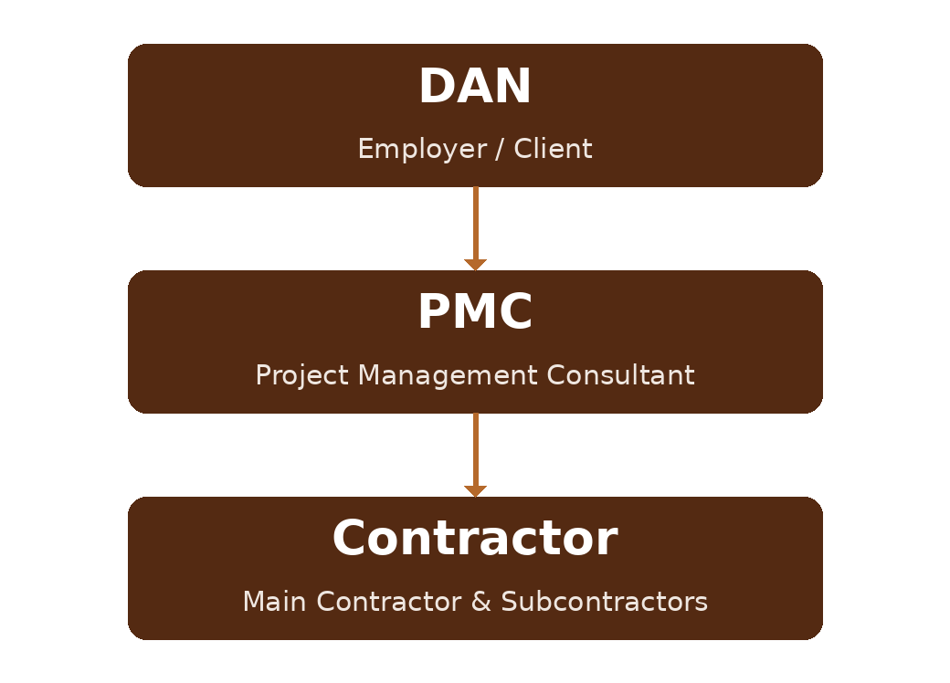
Figure A.3.2 Project Delivery Structure
Tier | Function / entity | Key quality responsibilities
Tier 1 — Executive | CEO / CDO | Strategic direction, policy approval, Vision 2030 alignment.
Tier 2 — Corporate | Delivery Director / HSSE-Quality function | Define QMS strategy, set objectives, lead audits.
Tier 3 — Programme/Project | Project Quality Managers | Deploy the QMS to projects; ensure PMC/contractor compliance.
Tier 4 — Delivery | Site QA/QC Engineers; PMC | Implement inspection and testing; supervise; report NCRs.
Tier 5 — Supply chain | Contractors, subcontractors, approved vendors | Execute works to DAN specifications and QMS requirements.

Annex A.4 — QMS Document Index
Tier | Document type | Reference | Owner
Tier 1 — Strategic | Quality Policy, QMS Manual, quality strategy | 01-000001-000000-DAN-QMN-MAN-000001 | Quality Manager
Tier 2 — Procedures | Internal Audit, Non-Conformity, Document Control | 01-000001-000000-DAN-{discipline}-{type}-{seq}-2xx | Quality Manager
Tier 3 — Execution | PQMP, ITP templates, method-statement guidelines, checklists | 01-000001-000000-DAN-{discipline}-{type}-{seq}-3xx | Project QA/QC Manager
Tier 4 — Records | NCR logs, inspection reports, training records, handover certificates | 01-DAN-FRM-QMS-4xx | Document Controller
Supporting registers | Risk & Opportunity, lessons learned, KPI tracker | 01-DAN-REG-QMS-5xx | Quality Data Analyst
External references | ISO 9001:2015, SASO/GSO standards, Saudi Building Code, Vision 2030 | — | Corporate Compliance
End of Quality Manual — Version v00. Document reference: 01-000001-000000-DAN-QMN-MAN-000001.

Revision History
Rev. | Date | Description of Change | Approved By
v00 | June 2026 | First issue — DAN Quality Management Manual, adapted to DAN's construction project-delivery scope and the DAN organisation and project structure, aligned to ISO 9001:2015. | Delivery Director

